**Personal Finance Manager**

Aliyan Qureshi

Contents

Introduction: 4

Scope : 4

Module Description: 4

Hardware & Software Requirements : 5

Screenshots: 5

Splash Screen: 5

Registration Screen : 6

Login Screen : 6

Dashboard : 7

Deposit & Withdraw : 7

Recent Transactions : 8

Investment : 9

Account Settings : 10

Architecture Diagram : 11

# Introduction:

Sukoon Finance App is a desktop application. This app simplifies finances. It tracks, analyzes, and manages all your transactions centrally, delivering critical financial data. This program keeps track of your income and expenses in great detail and offers suggestions on investing your money. It organizes and categorizes every transaction as your virtual assistant, giving you a clear financial picture. The app's user-friendly features, which include the ability to deposit and withdraw money with purpose, give you complete command of your financial situation.

# Scope :

* You can create an Account
* Login to an existing account by using uid & pin
* Settings are different for different roles
* Help you keep track of all your financial activities
* Allows to deposit or withdraw money for the purpose
* Can track all transactions with purpose and date on the Recent Transactions window in table format
* You can generate PDF Statement of transactions
* Automatic income deposit every month
* Suggest different Investment advice with recommendation and profit potential percent and risk percent
* Allow you to view the profile
* Allow you to update income or pin anytime
* You can exit Program Easily
* Very simple to use

# Module Description:

* **Splash Screen:** The program starts with a splash screen of the Logo, which redirects you to the registration window.
* **Registration Screen:** Register your account by adding your details, and the UID should be unique, and the pin should be 4 in length. You can also click the already registered option to log in to your existing account. Regex Validation is fully working !
* **Popups:** Registering a new account will give some popups to ask for more information depending on your selected role.
* **Login Screen:** The user Can log in to the existing account by entering UID and pin. If the user verifies, it redirects to the dashboard with account data.
* **Dashboard:** You can access the main functions of deposit, withdraw, recent transactions, account settings, investment advice, and exit option from the dashboard.
* **Deposit & Withdraw:** If the user selects any of these options, the program will pop up and ask for the amount and purpose and record it for future understanding. In withdrawal, the amount must be less than the account’s balance.
* **Recent Transactions  Screen:** This screen Shows all transactions (withdraw & deposit), with date, amount, and purpose in descending order by transaction date in table format.
* **Investment Advice Screen:** This Screen shows popular investment options, their rates, and maximum risk chance and profit potential. All Options are sorted by profit percentage. The one that has the most profit potential is highly recommended.
* **Account Screen:** This screen displays user details, including name, UID, pin, rôle, gender, and income. It also allows users to update their pin or income directly.
* **Exit:** The user can exit the program by clicking the exit button.

# Hardware & Software Requirements :

* Java JDK 16
* Java IDE Ex : NetBeans / IntelliJ IDEA

# Screenshots:

## Splash Screen:

## Registration Screen :

## Login Screen :

## Dashboard :

## Deposit & Withdraw :

## Recent Transactions :

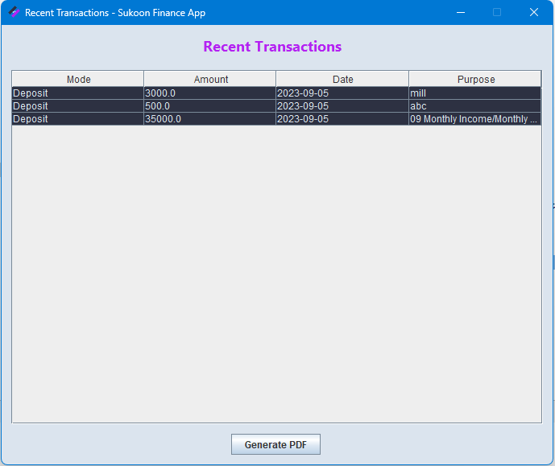

## Investment :

## Account Settings :

## Generated PDF :

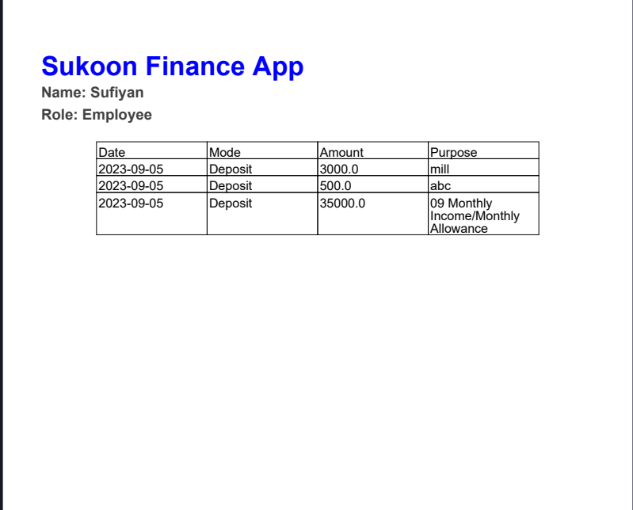

# Architecture Diagram :

